CLICK HERE, TYPE YOUR TITLE
First Author ª, Second Author ^{b},…
ª First affiliation, Address, City, Country, email
^{b} Second affiliation, Address, City, Country, email

ABSTRACT
Click here and insert your abstract

1 Introduction
Click here and insert your main text.
1-1 subtitles
Click here and insert your subtitles.
All the tables should be numbered
2 Materials and Methods
Table 1: add the title here
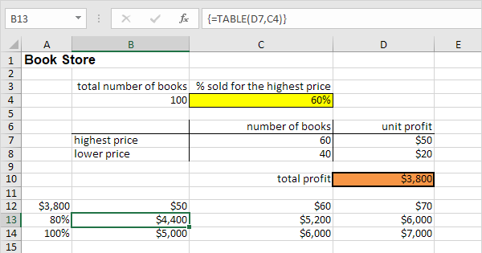

Figures should be numbered. The figure number and caption should be typed below the figure in 8 pt.
3 Experiments
Fig. 1: picture of ….
4 Results and Discussion
Equations and formulae should be typed in Mathtype, and numbered consecutively in parentheses on the right hand side of the page. They should also be separated from the surrounding text by one space.
${ K}_{ω}=\frac{1}{2}Iω^{2}$ (1)
5 Conclusion
Click here for conclusion font
References
Stewart, D., A., (1973). A computer study of egg shell forces at impact on cage floors. British Poultry Science, 14(5), 431-444.

